Hero section

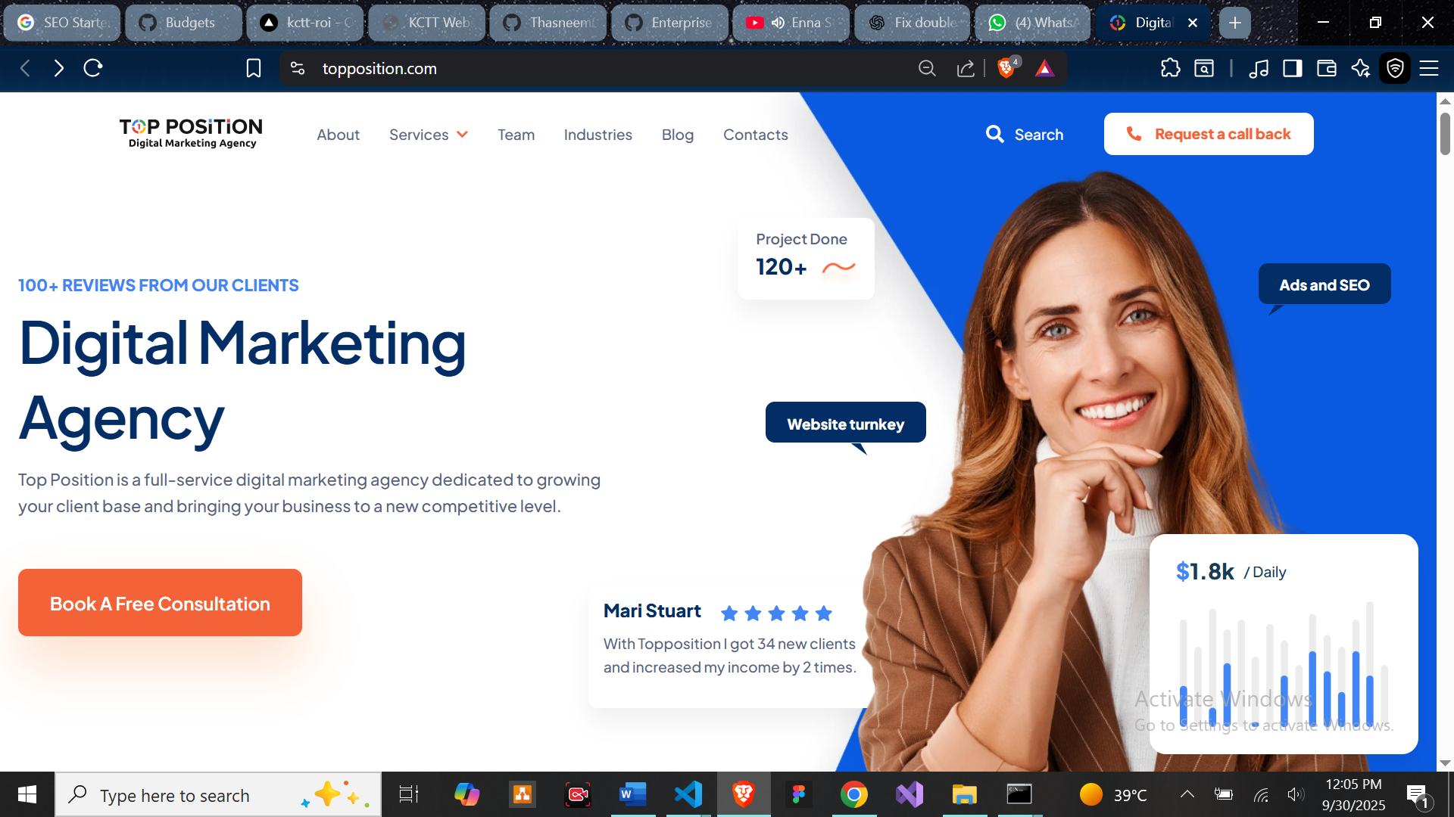

Our client section

Digital Marketing Means

**No more cold calls**

According to the Harvard Business Review, cold calling is ineffective 90% of the time. With digital marketing solutions, you can reach interested customers 24/7 through online ads, social media, and other platforms even as you sleep.

**More new & repeat customers**

With the help of digital marketing companies like Top Position, you can reach a wider audience on the internet. Your business will be known to new customers, you’ll get to nurture customer loyalty to encourage repeat purchases.

**Excellent return on investment**

With the help of the best digital marketing agency, your brand will be exposed to the right audience. This translates to higher engagement, more leads, and more profits for your business. You’ll enjoy all these without any technical work on your part.

**Stand out from competitors**

Most of your competitors are already partnering with digital marketing agencies to boost their sales. Our digital marketing firm can help by ensuring your business has the best online presence.

Business Improvement

Our client’s project

Our digital marketing services

Choose the digital marketing agency

**Why Choose Top Position Digital Marketing Agency?**

Top Position is a team of digital marketing specialists who are passionate about seeing your business grow. We want your business to succeed, much like our valued clients. Here’s why business owners like you consider us one of the top digital marketing firms:

**Results-driven marketing**

Everything we do is designed to generate more leads, calls, appointments, and sales for your business. Our mission is to provide you with steady revenue.

**Best-in-class technology**

We provide our clients with the winning combo of highly skilled specialists and custom-built systems to power up their marketing campaigns.

**Full-service marketing solutions**

Top Position will be your one-stop shop for all your digital marketing needs. We can adapt to your marketing needs as your business grows.

**100% transparent reporting**

You’re always on top of your results and budget without all the work on your part. We will also assign a dedicated project manager for you.

There is a background in the behind

Digital Marketing Services vs traditional marketing

**Digital Marketing**

**Marketing through the internet**

(examples: social media, email, search engine, etc.

**Easy control of your spending**

You can stop any campaign immediately if it’s not working (preventing losses)

**Faster results**

Get instant exposure within hours

**Easy to measure results**

You’ll know how many people saw your ads, how many clicked, how many purchased, and more in real time.

**Bigger audience reach**

Get exposure for your business both locally and nationally – in any location.

**Highly customizable**

You can easily change what doesn’t work and refine your campaigns to get more customers.

**Allows for easier customer communication**

You can easily communicate with your customers 24/7 through various online platforms.

**Gives you control over who sees your ads**

Your brand will be exposed to those who are actively searching for similar products or services.

**Traditional Marketing**

**Limited to offline marketing**

(examples: telephone, print, billboards, flyers, broadcasts, etc.).

**Higher costs**

You pay a big price upfront without any guaranteed results.

**Longer waiting periods**

Takes weeks or months to set up and get actual results

**Difficult to measure results**

Limited tracking options, and you won’t know exactly how many people saw your ads

**Limited reach**

Limited customization and too expensive if you’re aiming for the national level

**Can’t be updated easily**

Higher risk since materials can’t be updated easily once it’s printed, aired, or installed.

**Communication is only one-way**

Customers don’t have an option to instantly connect with you upon seeing your advertisements.

**Limited control over ad exposure**

It’s almost impossible to filter who can see your ads once it’s been put out.

Growing business

**How am I going to be billed for the digital marketing services I will avail?**

This depends on what service you availed from us. For example, our SEO services are on a subscription basis, which will be charged to you at the beginning of the applicable month. Meanwhile, for our website development service, we require a 50% down payment, and the remaining 50% will be settled once we deliver all the inclusions of the package.  
If you want to know more about our pricing model, feel free to book a consultation with us. Our digital marketing consultancy specialist will answer all your questions.

**Where can I find a digital marketing agency near me?**

Wherever you are in the United States, Top Position would be a smart choice. We are currently headquartered in West Palm Beach, Florida, but our reach extends nationally. Don’t hesitate to book a consultation with us if you want to know how we can cater to your service area/s.

**Who owns the website you’re going to build for my business?**

You’ll own everything on your website and the website itself. Still, we will provide you with the convenience of having specialists manage everything, so you don’t have to worry about the technical aspect. This makes our web design services a great investment for your business, whether you decide to work with us long-term or at your discretion.

**I’m not ready for a full package yet, can I choose just one service?**

Of course! You’re free to sign up for our complete digital marketing package or simply choose only the services you need at the moment. At the same time, you can always upgrade with more services once you’re ready to expand your marketing efforts.  
All our services are flexible and can be tailored to your needs. Let us know your marketing goals, and we will create a custom plan for your business.

**What kind of report do you provide?**

For our SEO services, we provide monthly reports to let you see your growth each month. For our advertising campaigns, we can provide you with daily, weekly, monthly, quarterly, and even yearly reports upon request. Rest assured that we will update you regularly on your marketing campaigns’ status.

**How do you measure the results of your campaigns?**

We have a robust analytics system where we monitor every campaign we launch for our clients. This is also included in the reports we will provide regularly.

**How can I reach you if I have concerns about my campaigns?**

Once you decide to work with us, we will add you to our communication platform so you can easily reach out to the project manager assigned to you. This way, we can also give you updates on the get-go, making everything easy and convenient.

**How much do your digital marketing consulting services cost?**

Feel free to check the packages available on our service pages. If you wish to get custom services, book a consultation with us, and we will provide you with a custom quote.

Footer

